**QUẢN TRỊ VÀ BẢO TRÌ HỆ THỐNG**

**Họ và tên: LÊ QUỐC ĐẠI**

**MSSV: CNTT2211047**

# **4. DNS Server**

## **4.1. Installing and Configuring the DNS Service**

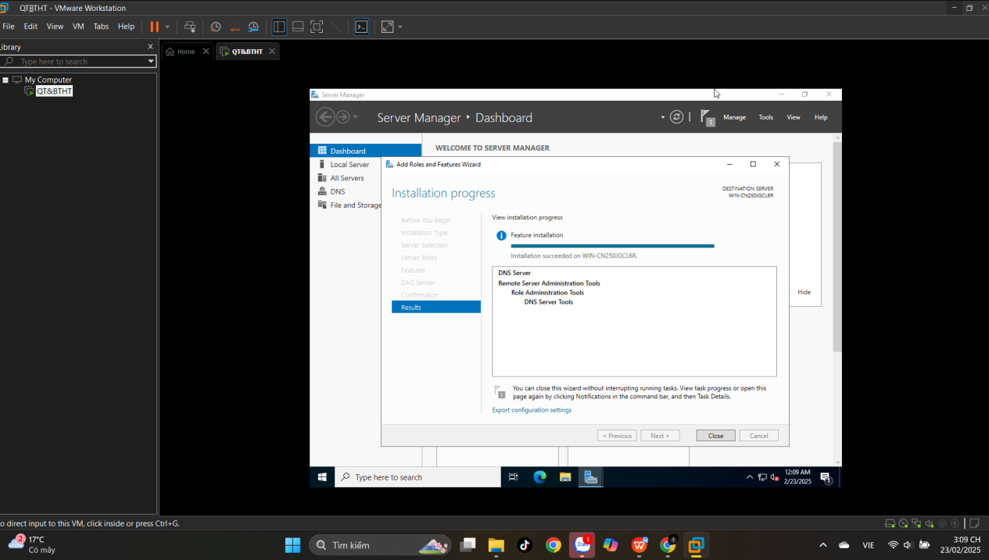

## **4.2. Configuring a Zone for Dynamic Updates**

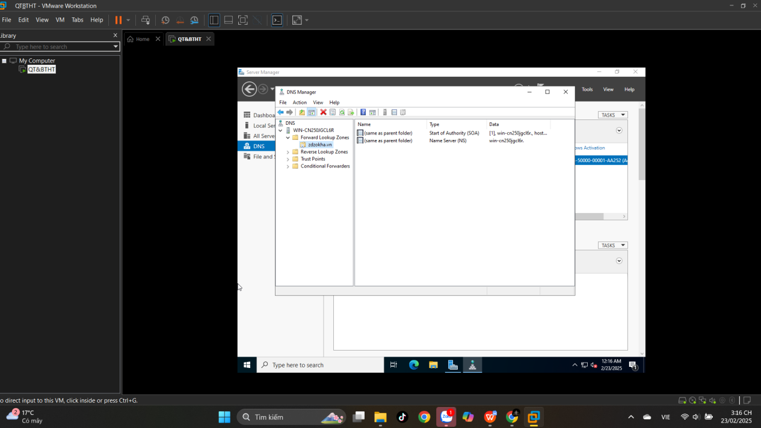

## **4.3. Creating a Delegated DNS Zone**

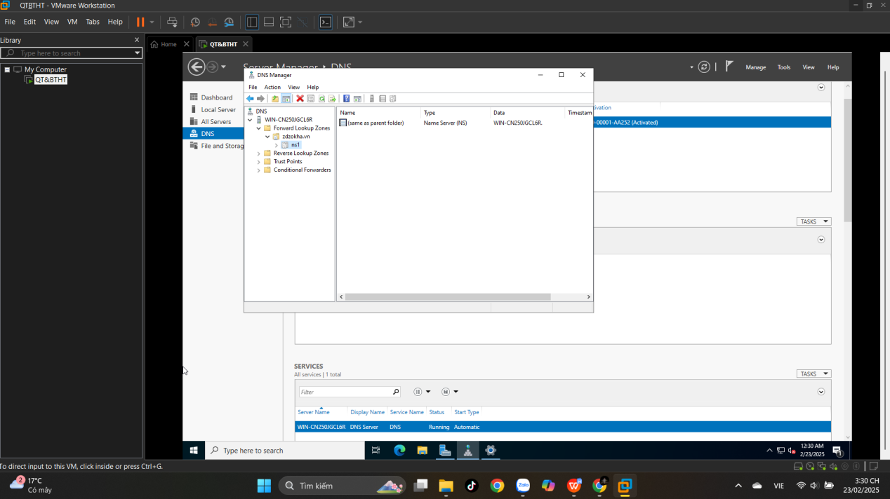

## **4.4. Manually Creating DNS Records**

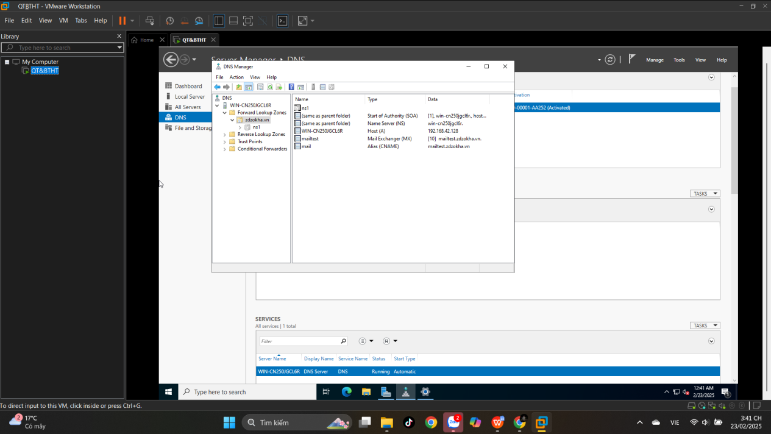

# **5. Active Directory**

## **5.1. Promoting a Domain Controller**

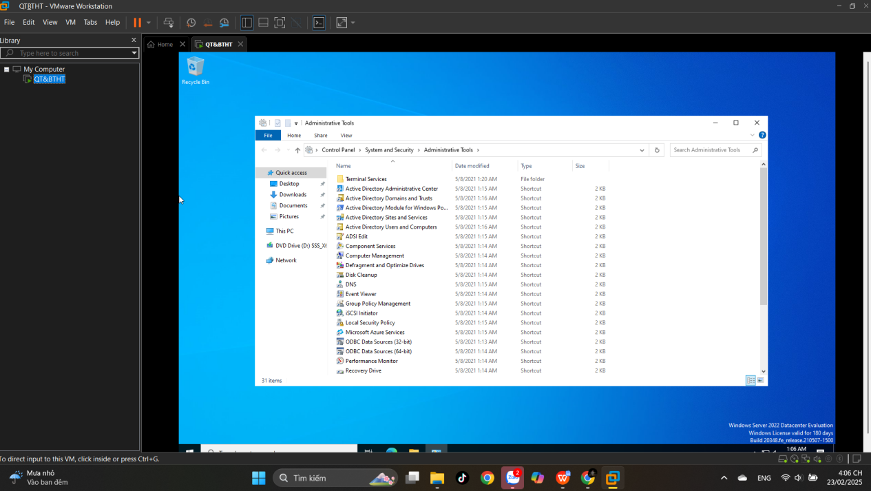

## **5.2. Viewing the Active Directory Event Log**

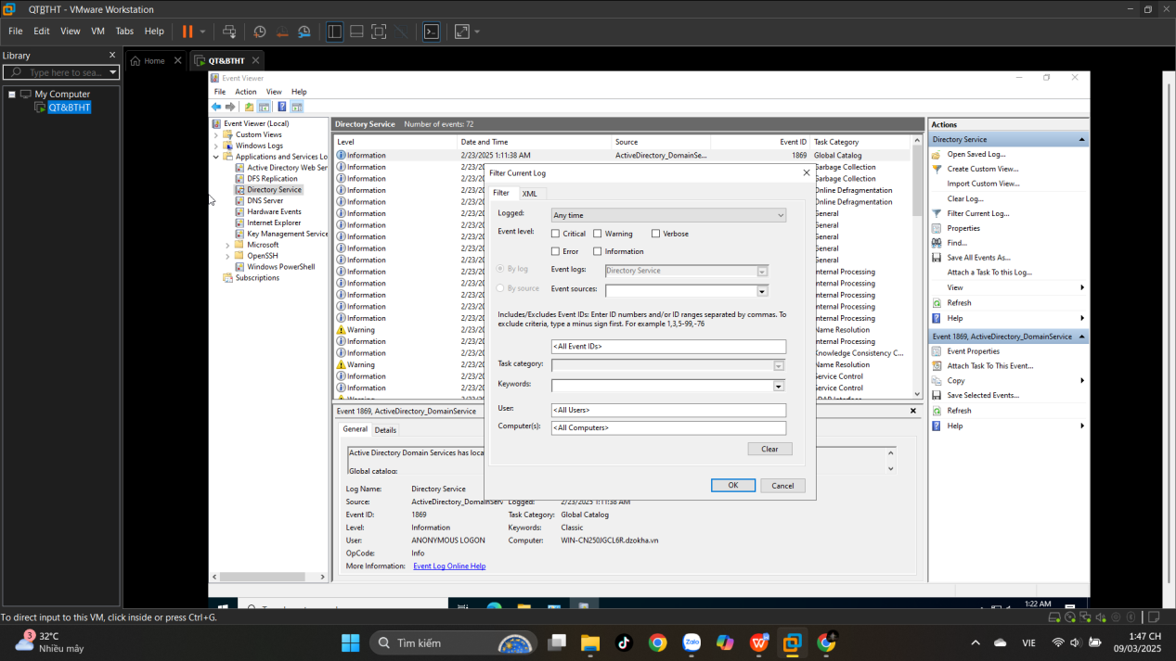

## **5.5. Configuring DNS Integration with Active Directory**

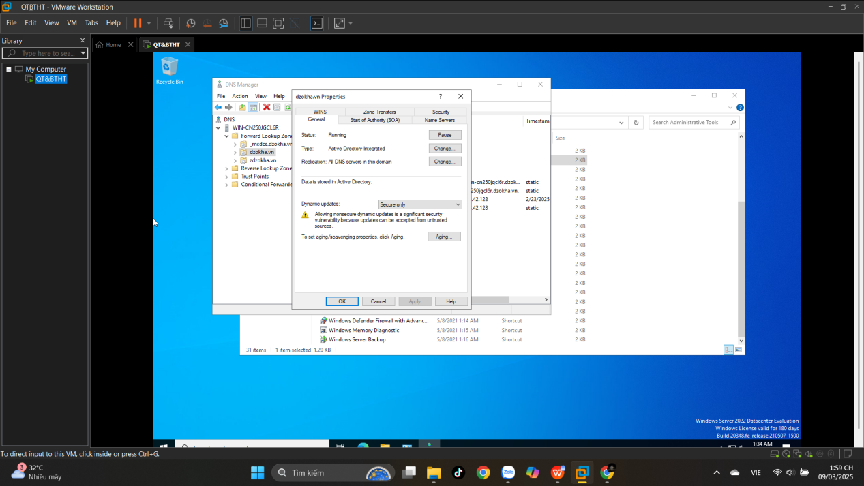

**5.6. Creating an OU Structure**

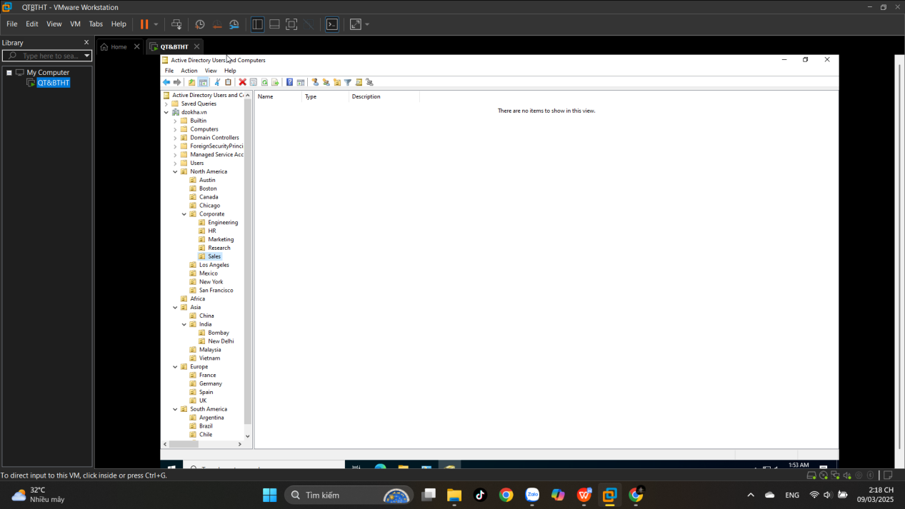

**5.7. Modifying OU Structure**

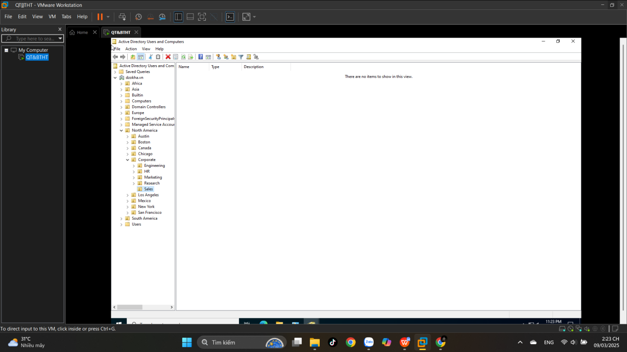

## **5.8. Using the Delegation of Control Wizard**

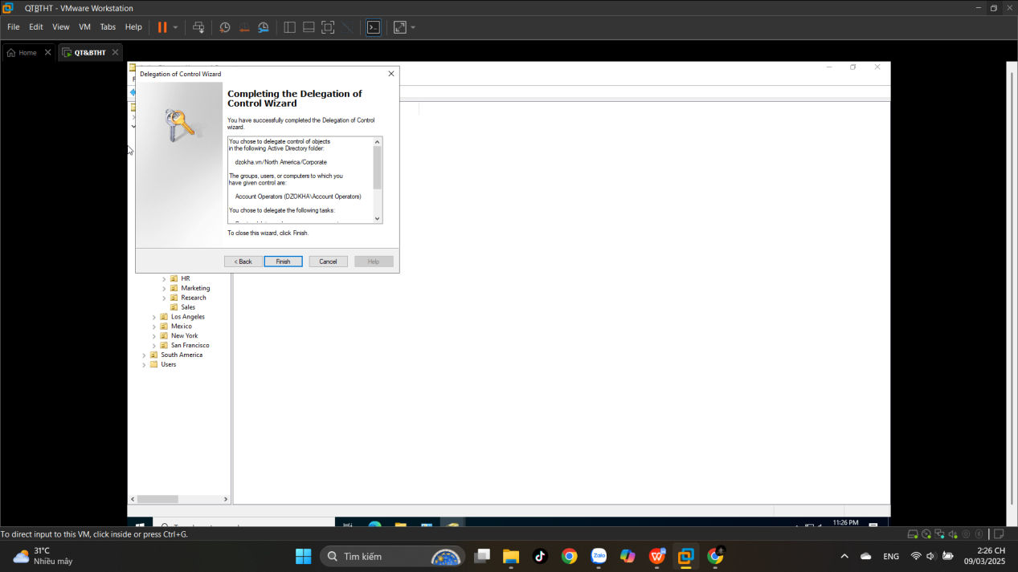

**5.9. Delegating Custom Tasks**

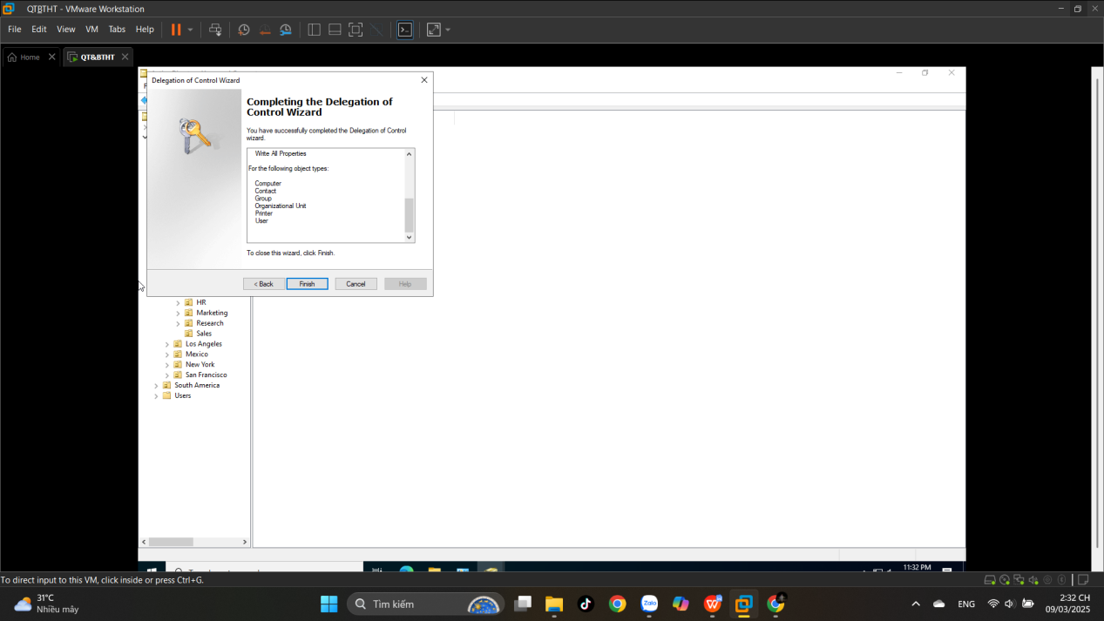

## **5.10. Creating Active Directory Objects**

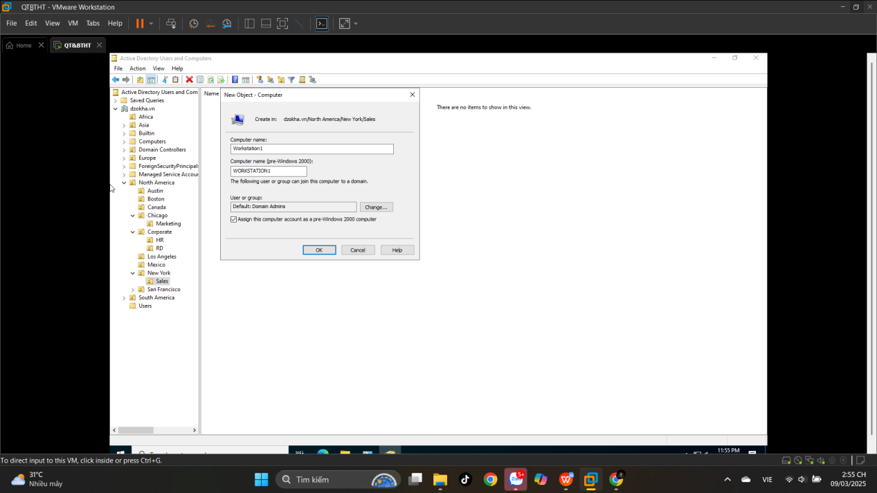

## **5.11. Creating a User Template**

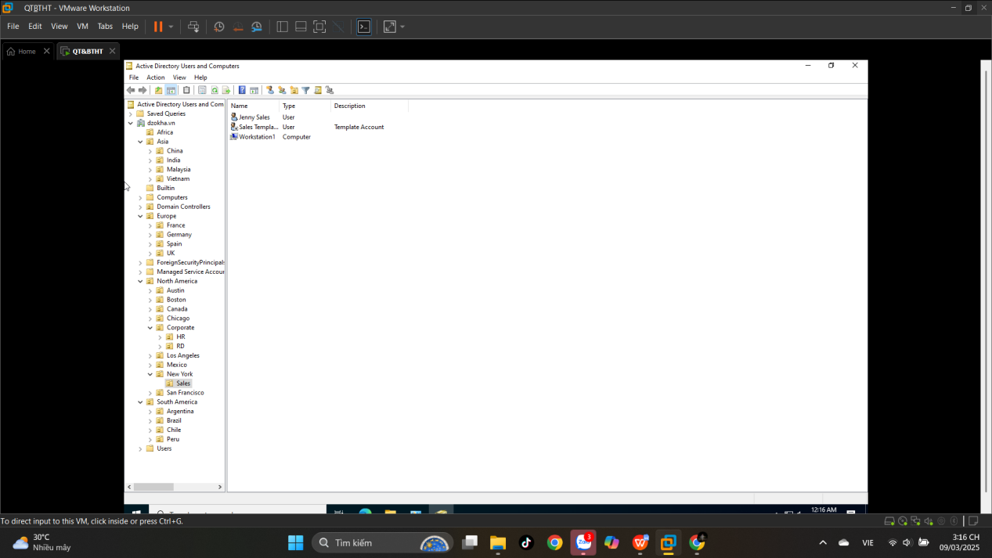

**5.12. Managing Object Properties**

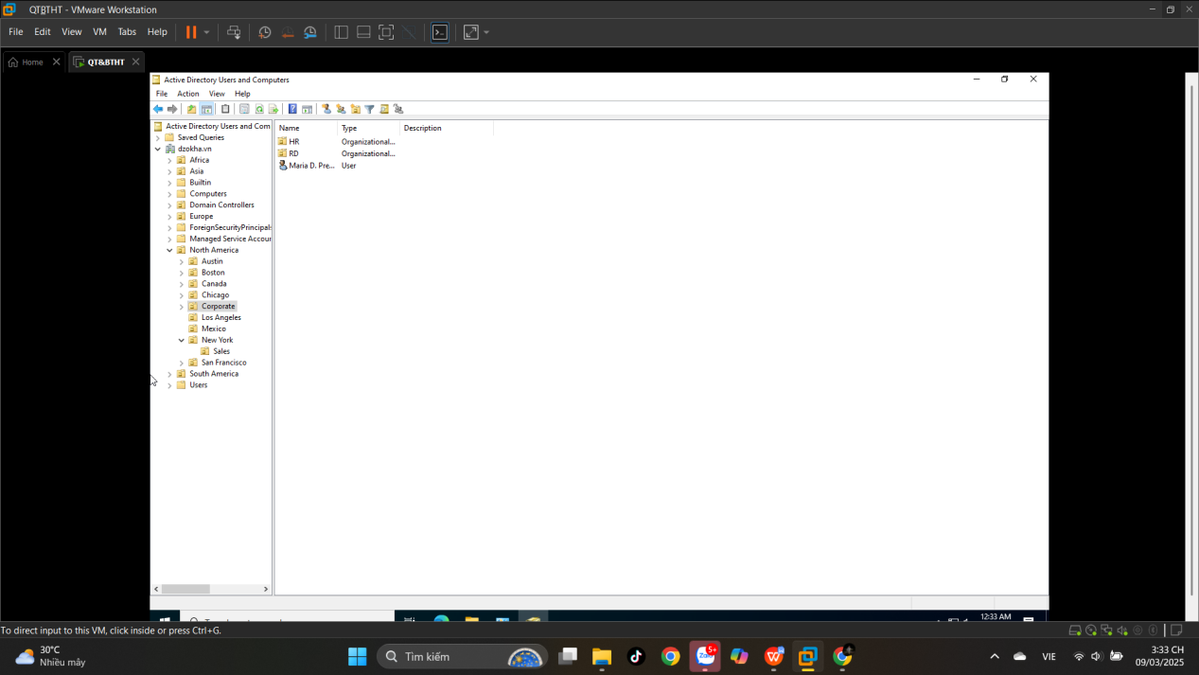

**5.13. Moving Active Directory Objects**

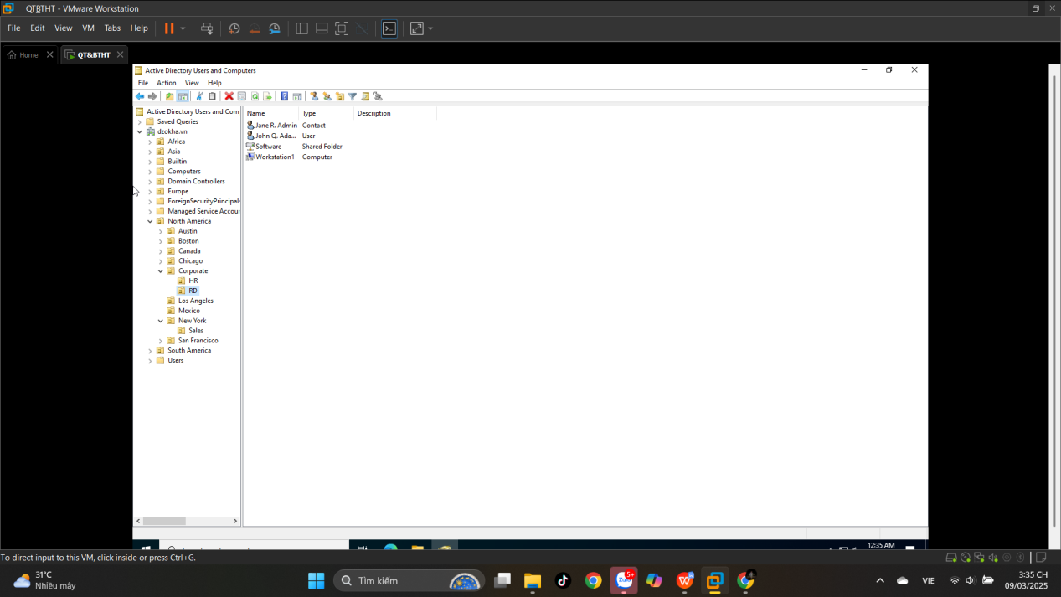

## **5.14. Resetting an Existing Computer Account**

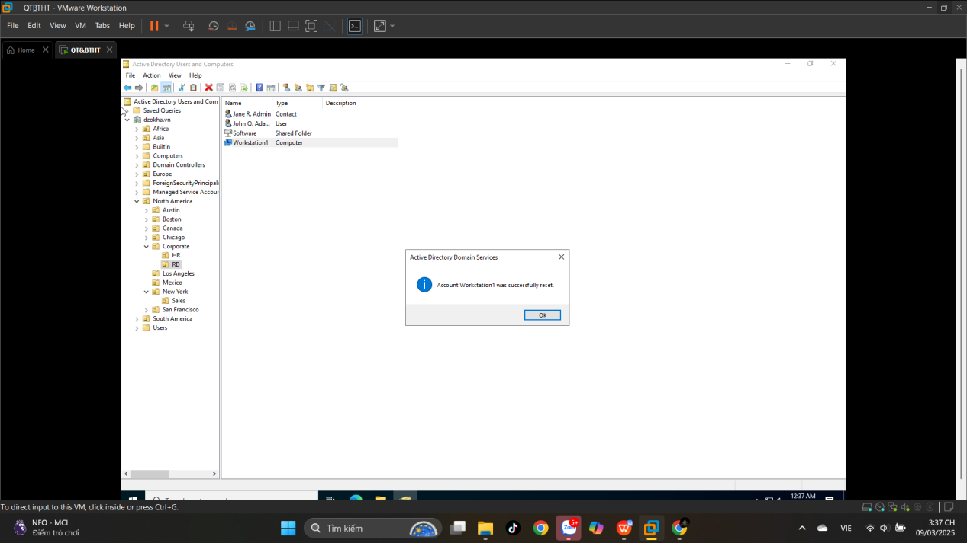

## **5.16. Creating and Publishing a Shared Folder**

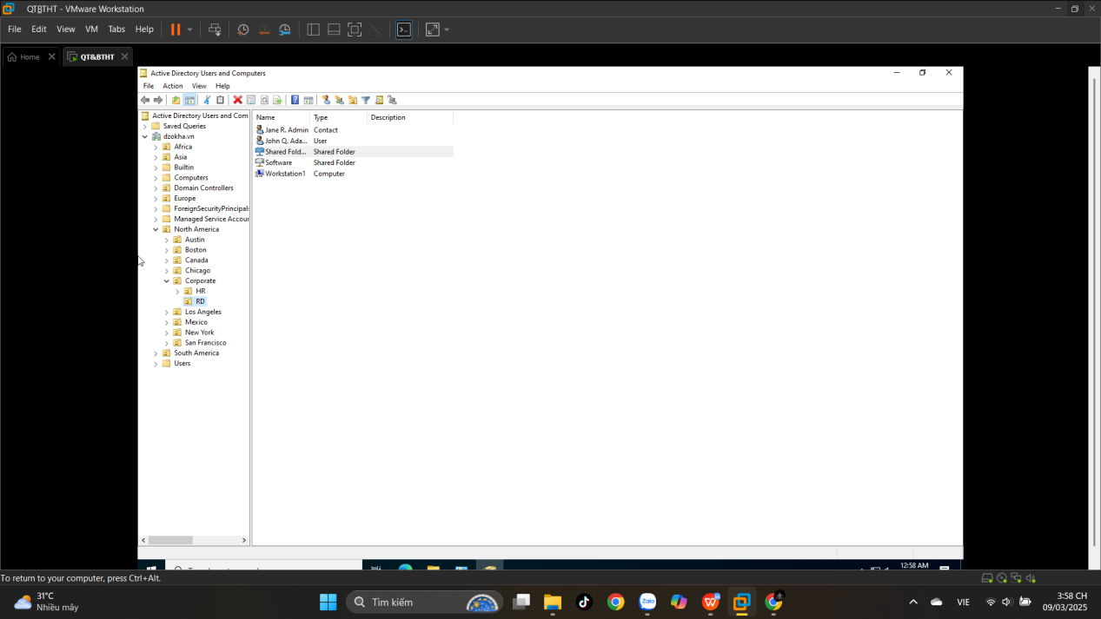

# **6. DHCP**

## **6.1. Installing the DHCP Service**

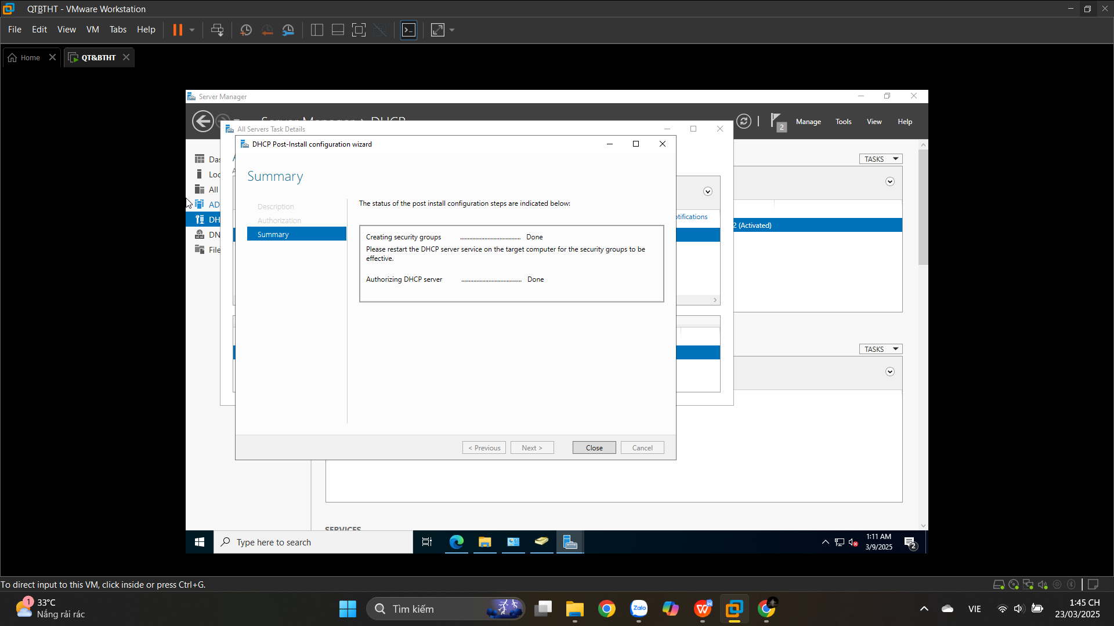

## **6.2. Authorizing a DHCP Server**

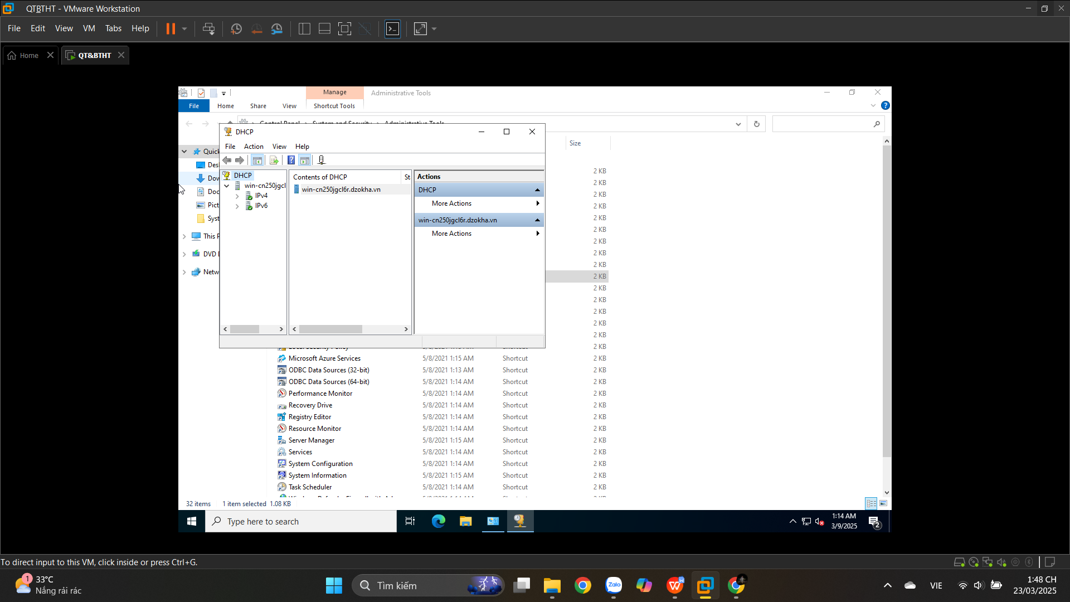

**6.3. Unauthorizing a DHCP Server**

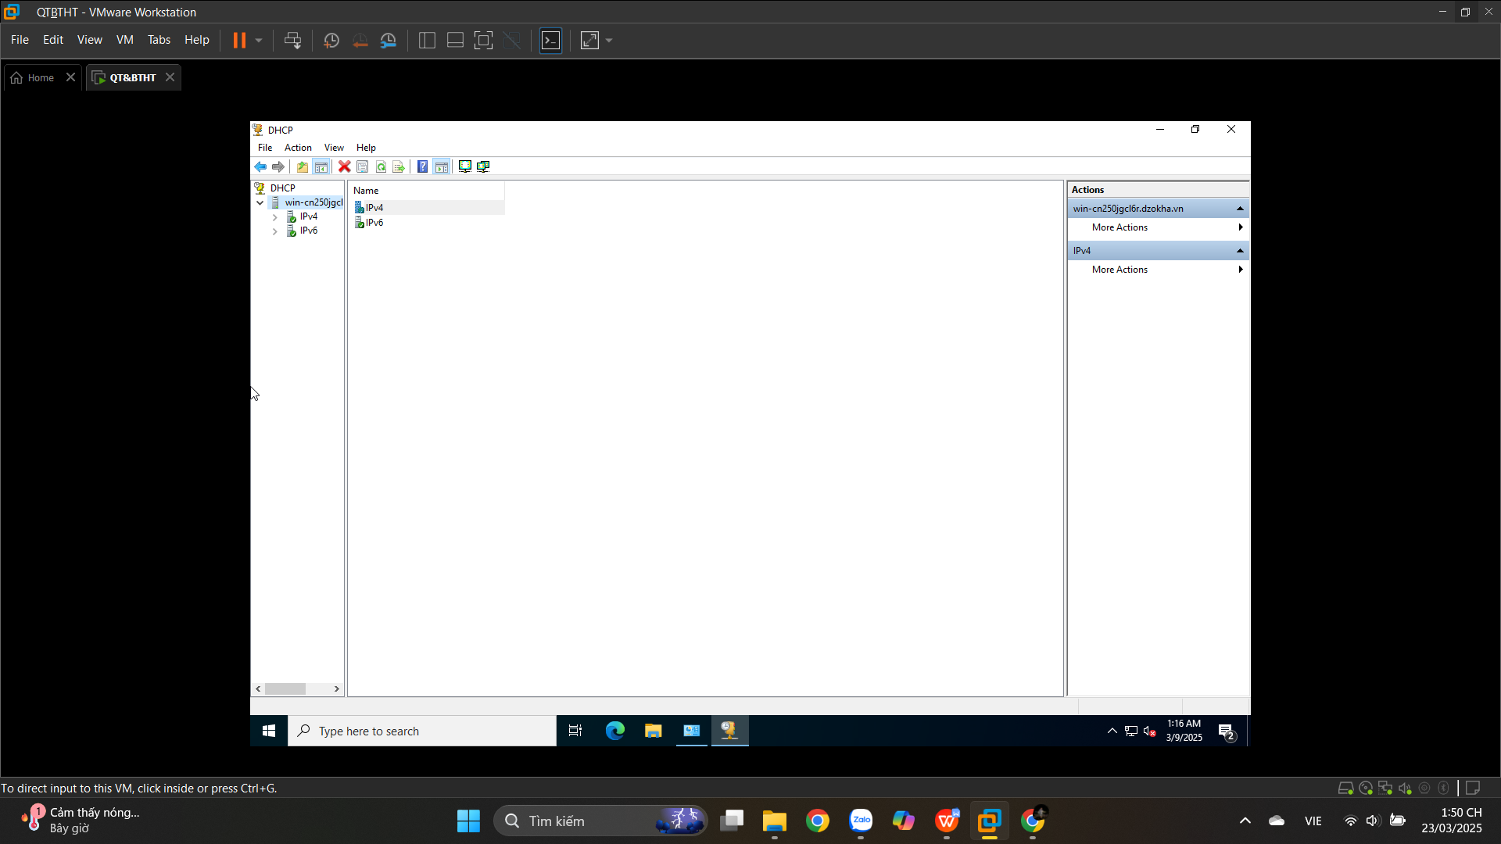

**6.4. Creating a New Scope**

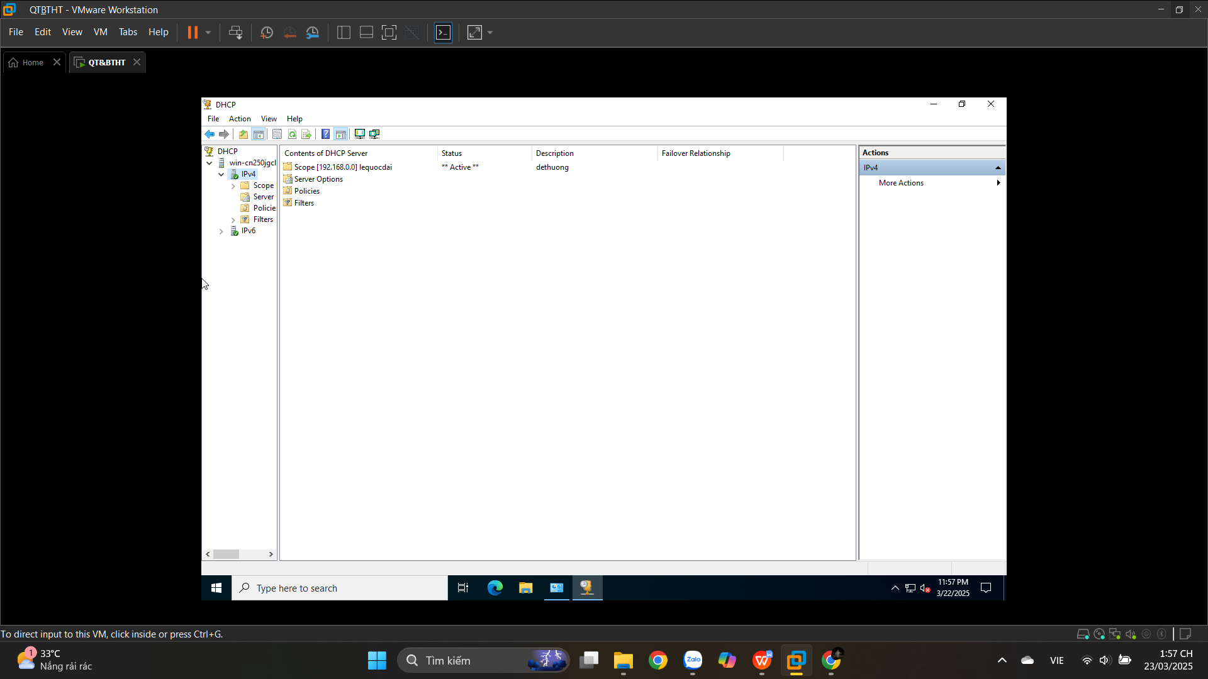

## **6.5. Creating a Superscope**

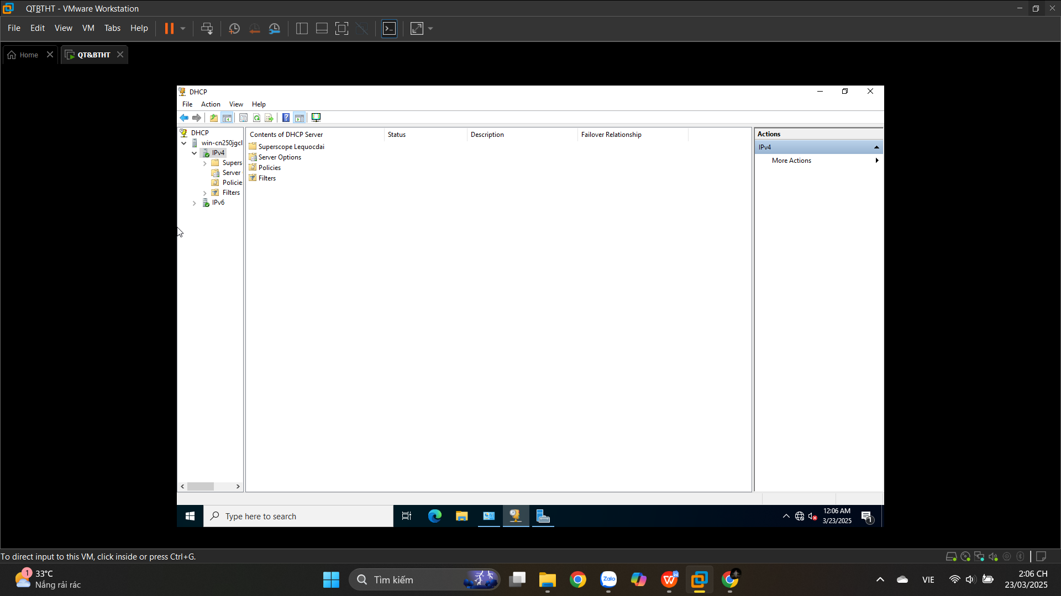

## **6.6. Creating a New Multicast Scope**

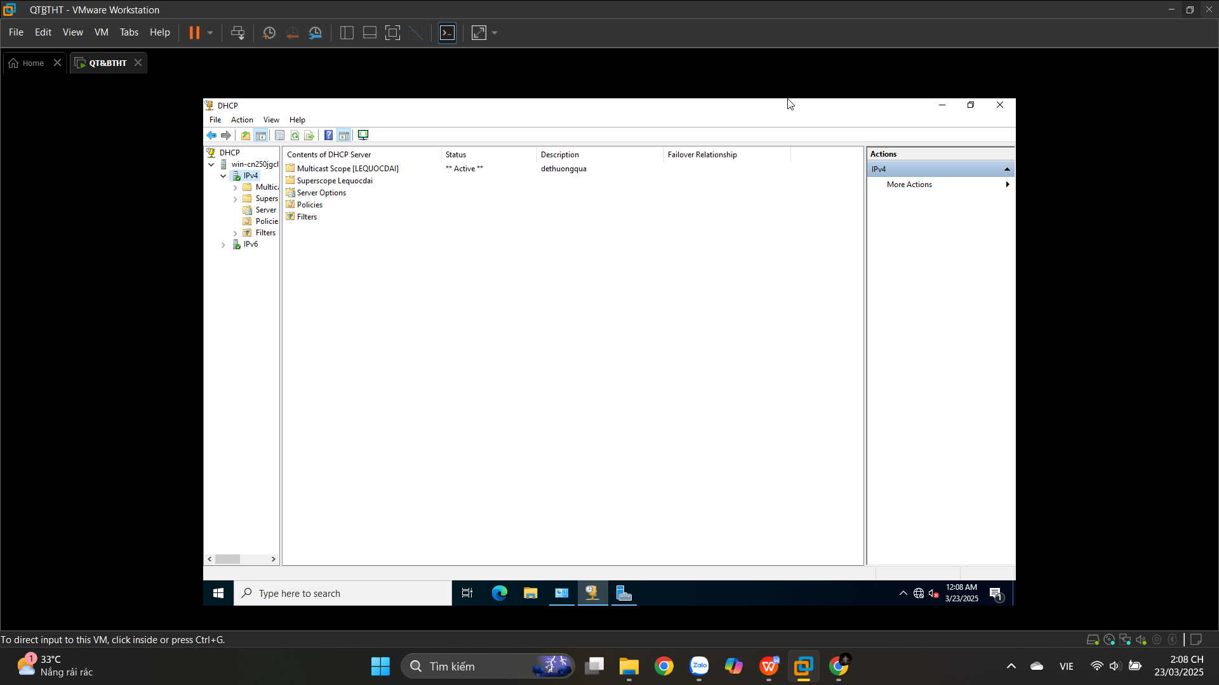

## **6.7. Enabling DHCP-DNS Integration**

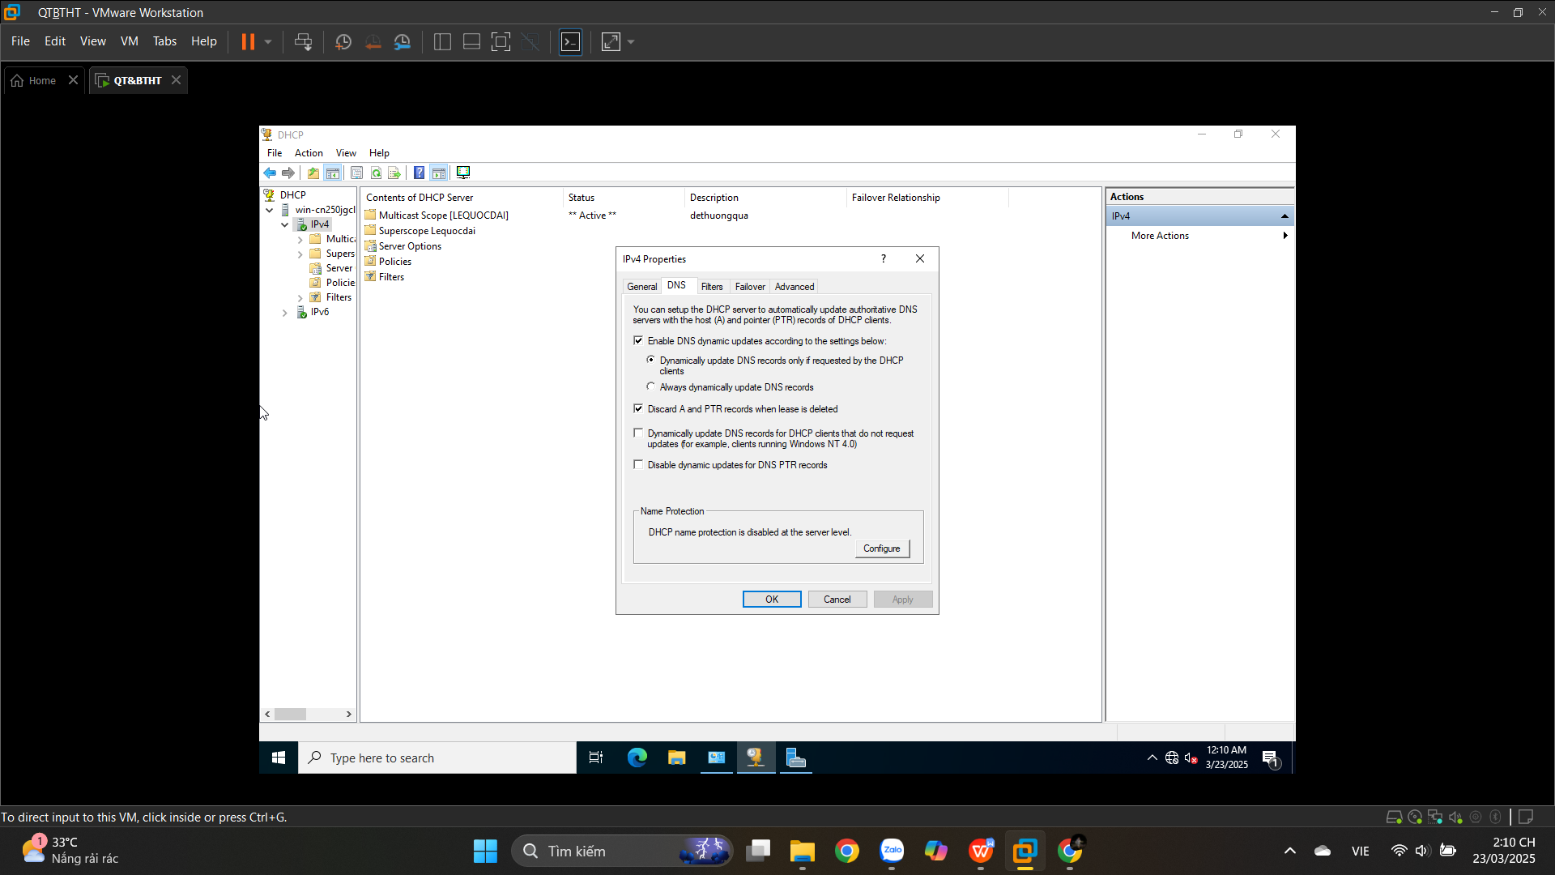

## **6.8. Configuring DHCP Filtering**

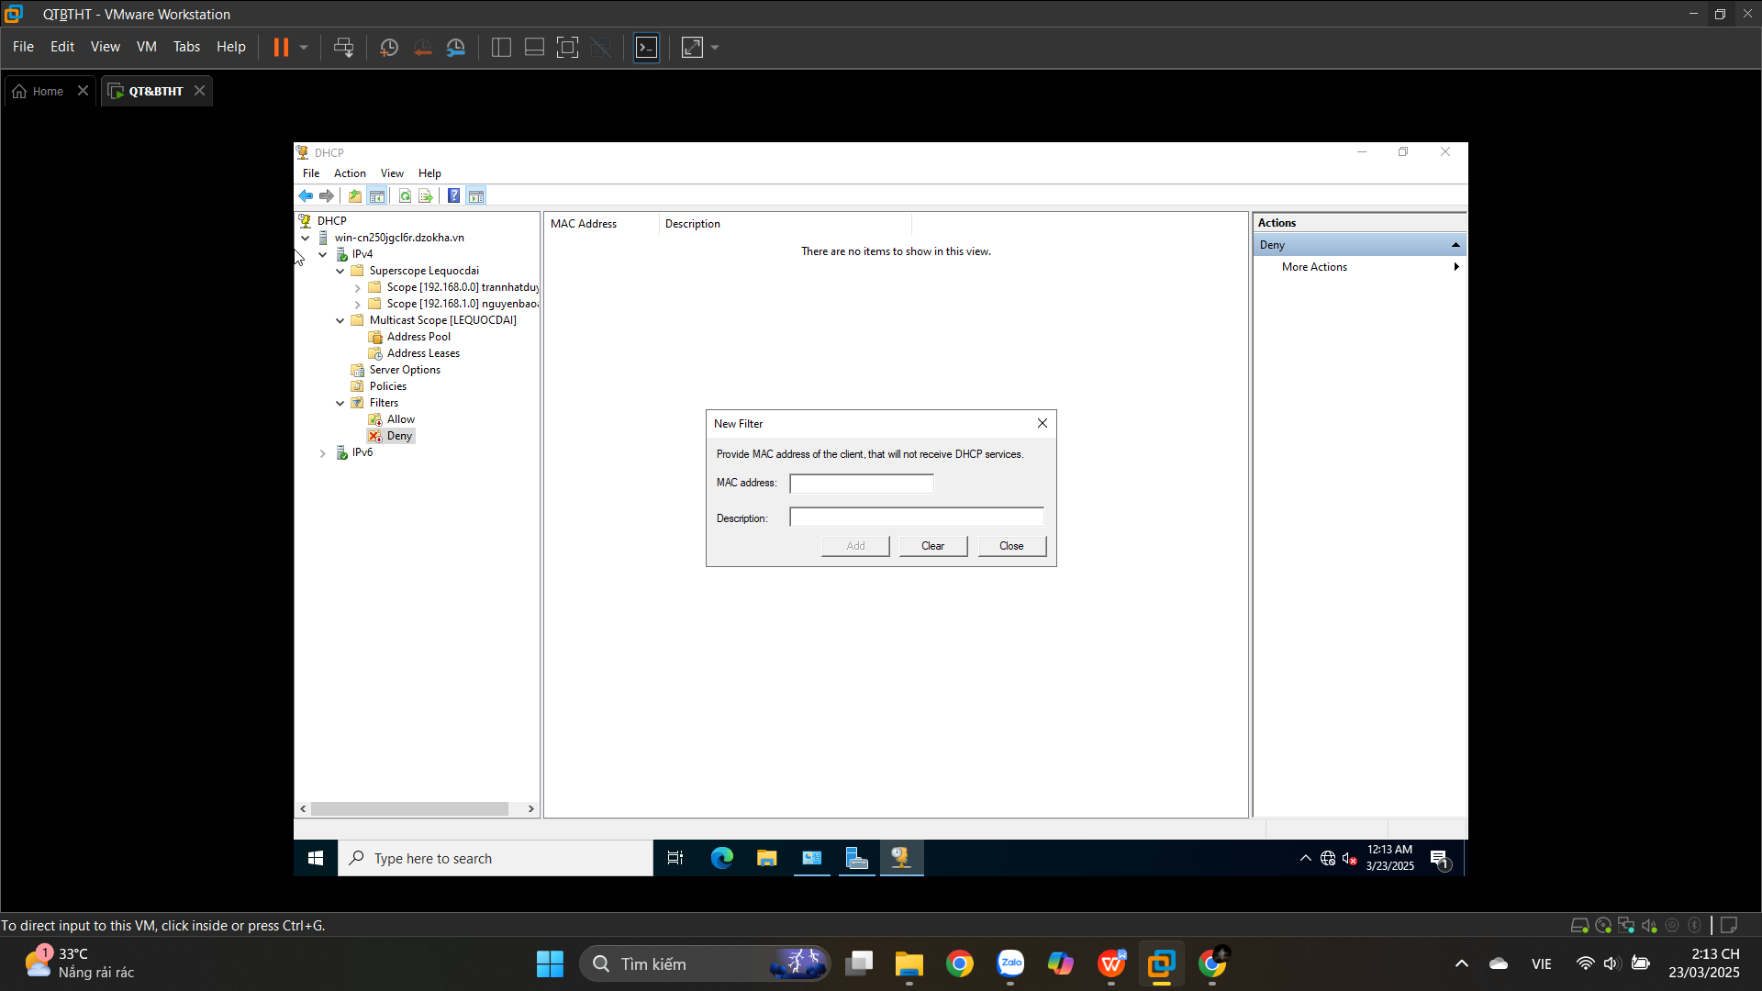

## **6.9. Enabling DHCP Name Protection**

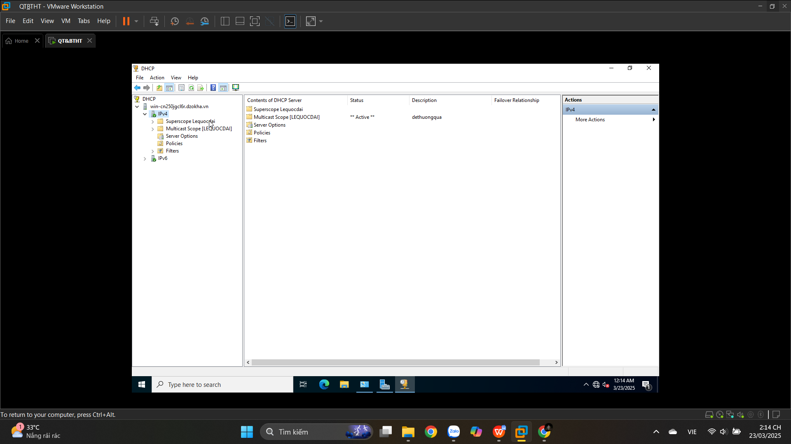

# **Dịch vụ cho máy chủ**

## **Cài dịch vụ IIS**

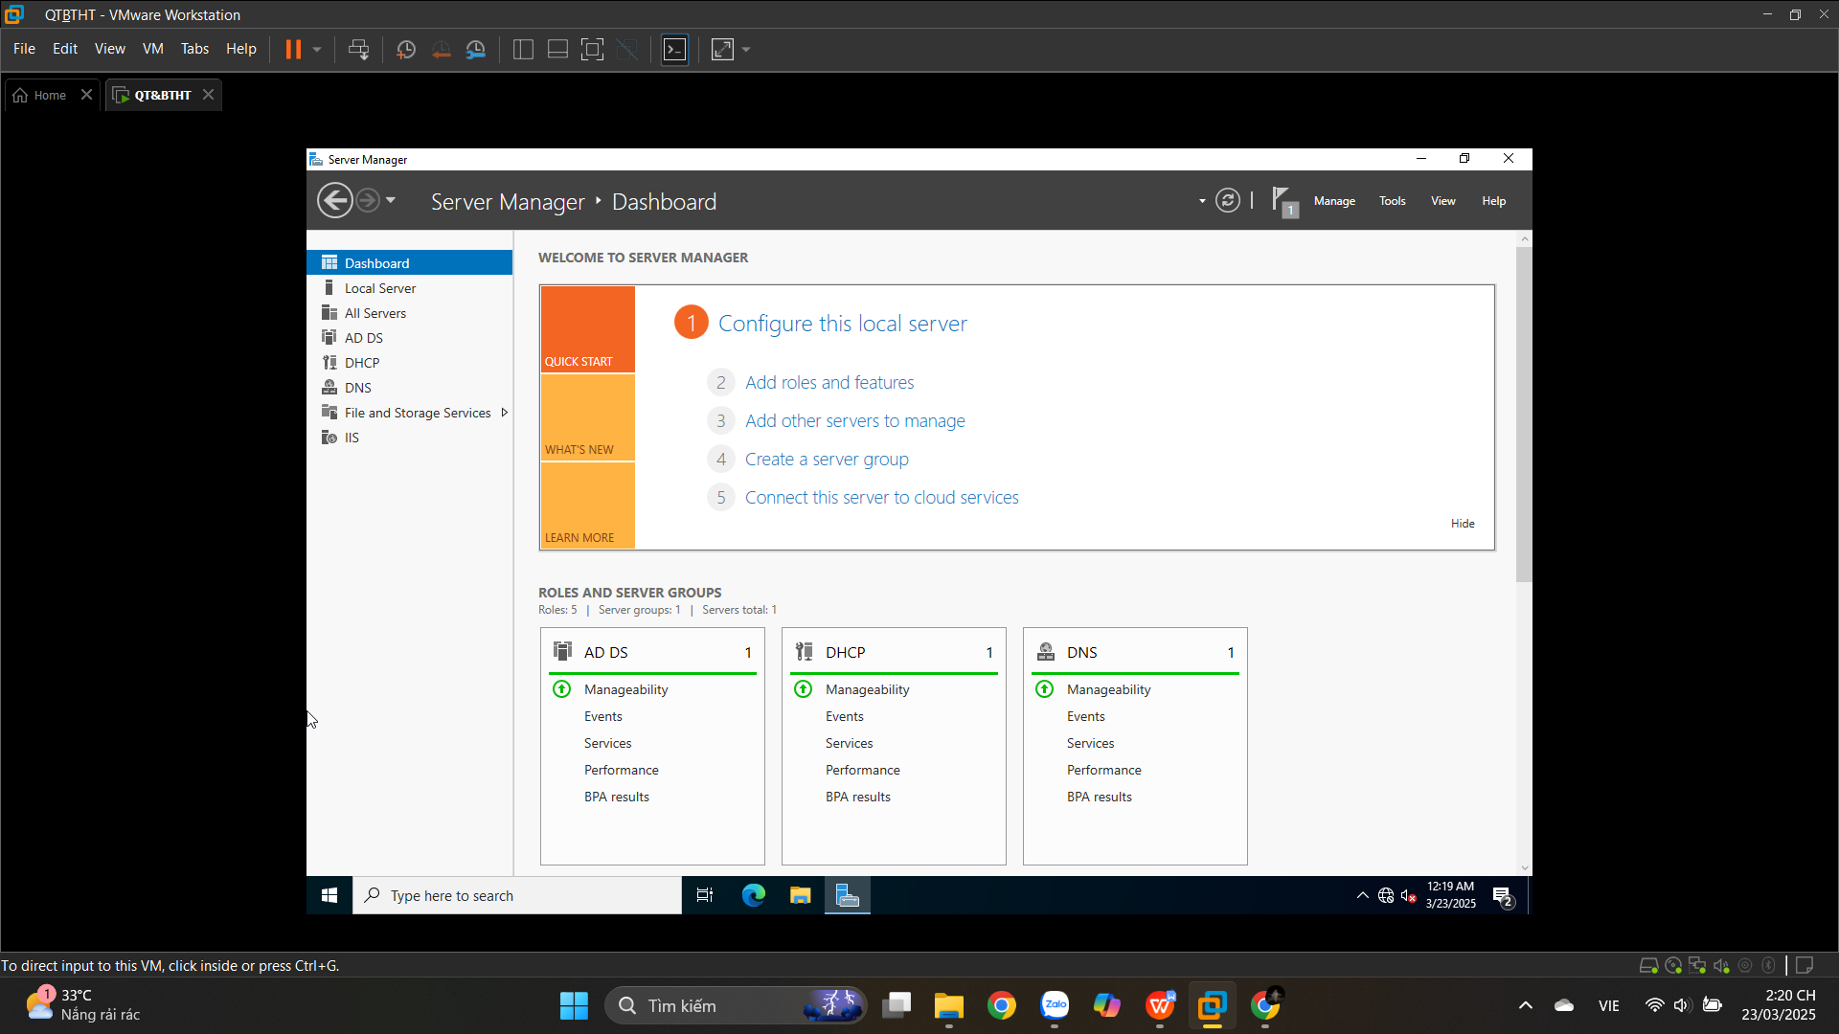

# **10. Group Policy**

## **10.1. Creating a Group Policy Object Using the GPMC**

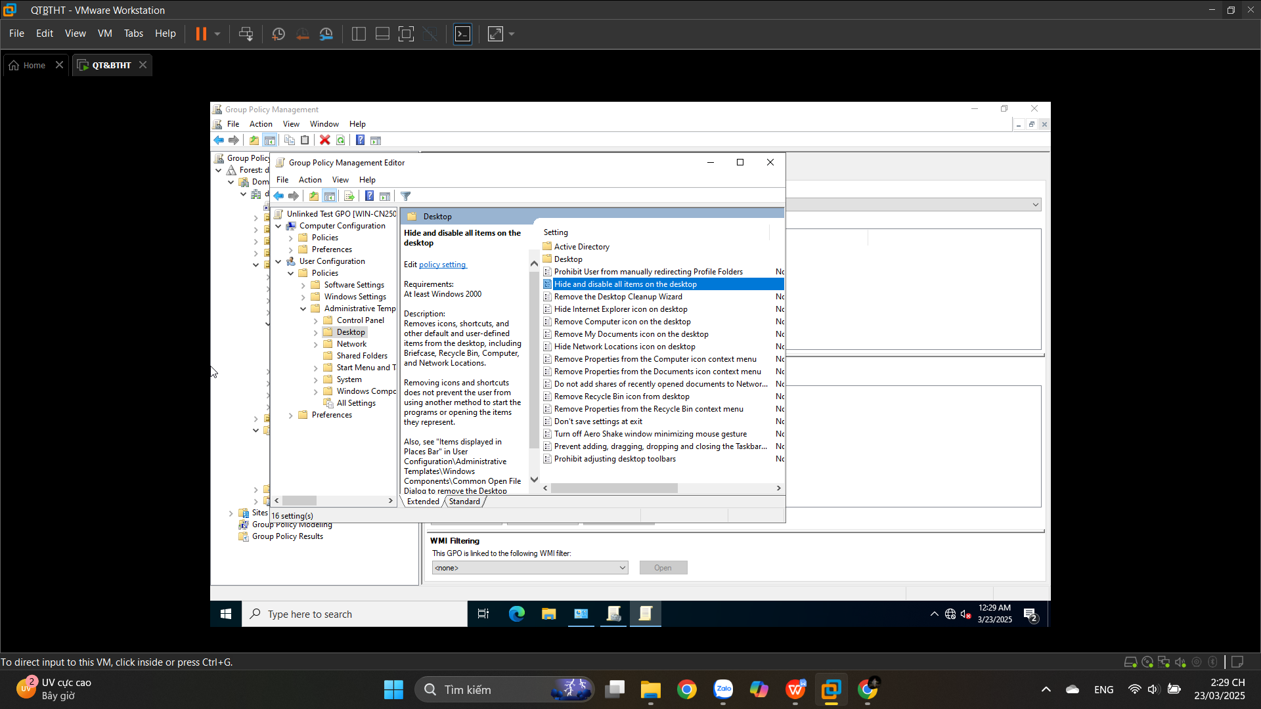

**10.2. Linking Existing GPOs to Active Directory**

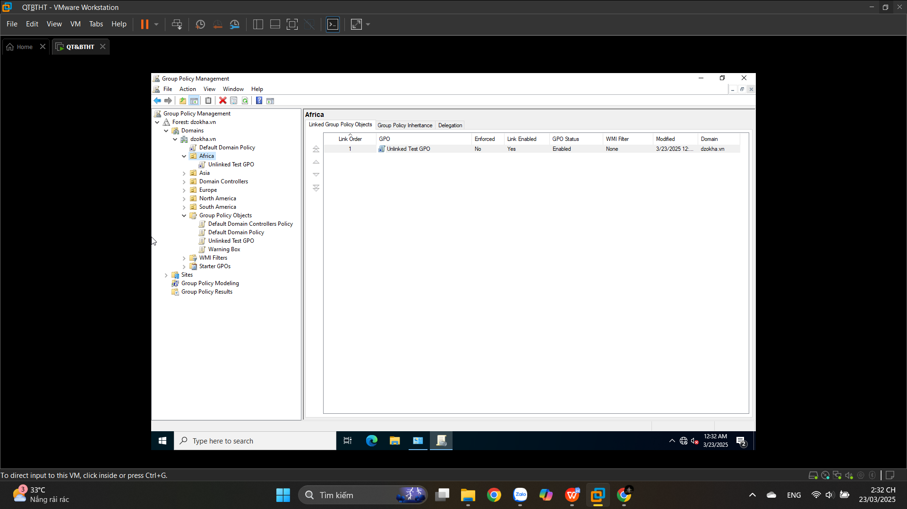

## **10.3. Filtering Group Policy Using Security Groups**

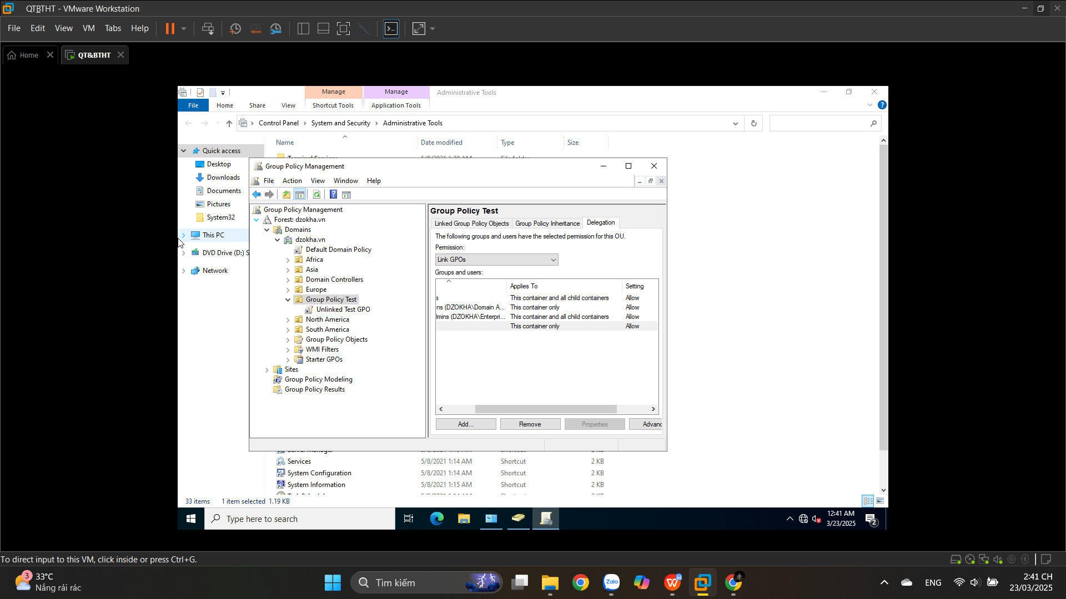

## **10.4. Delegating Administrative Control of Group Policy**

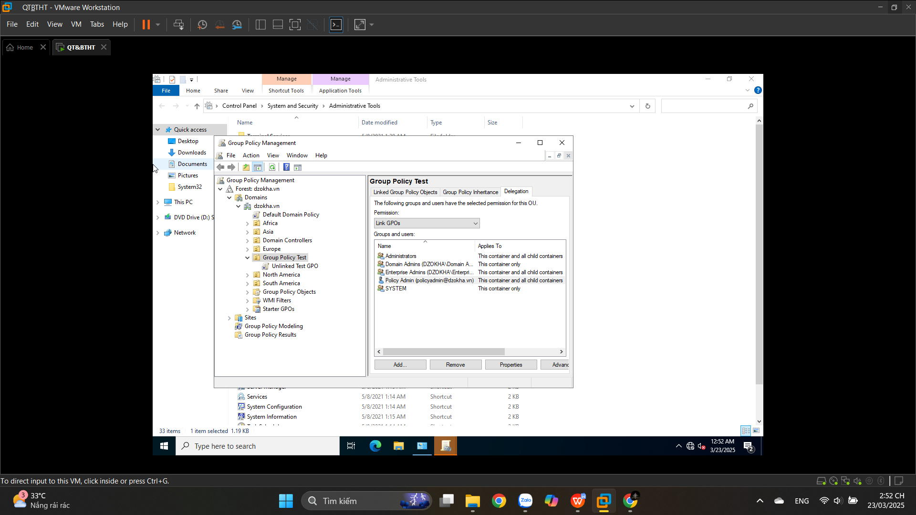

**10.5. Configuring Automatic Certificate Enrollment in Group Policy**

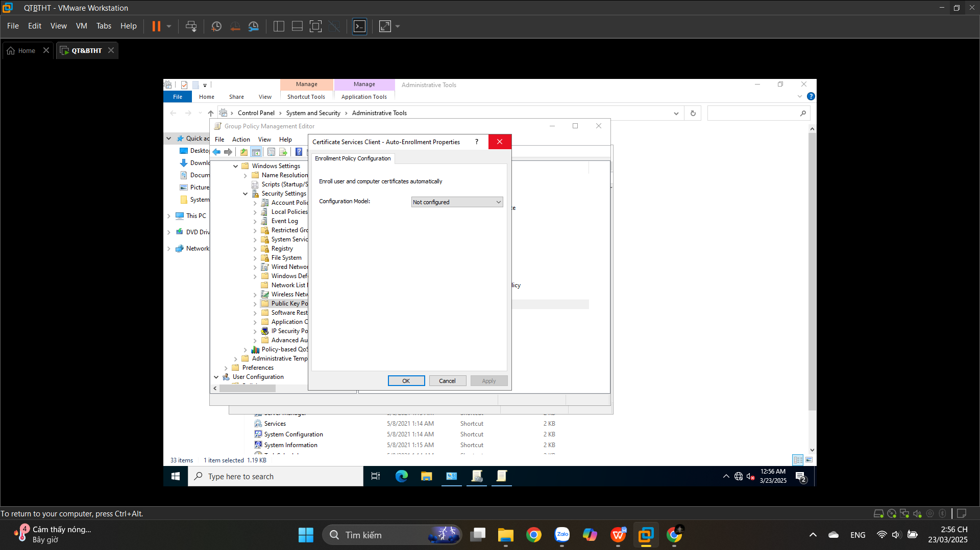

**10.6. Configuring Folder Redirection in Group Policy**

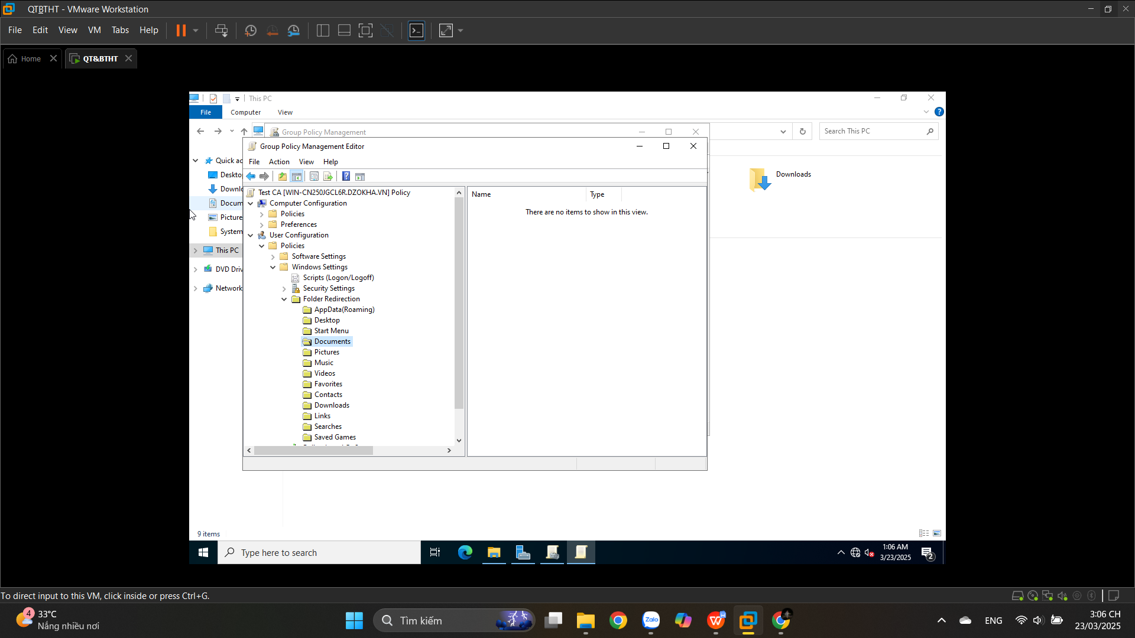

**10.7. Creating a Software Deployment Share**

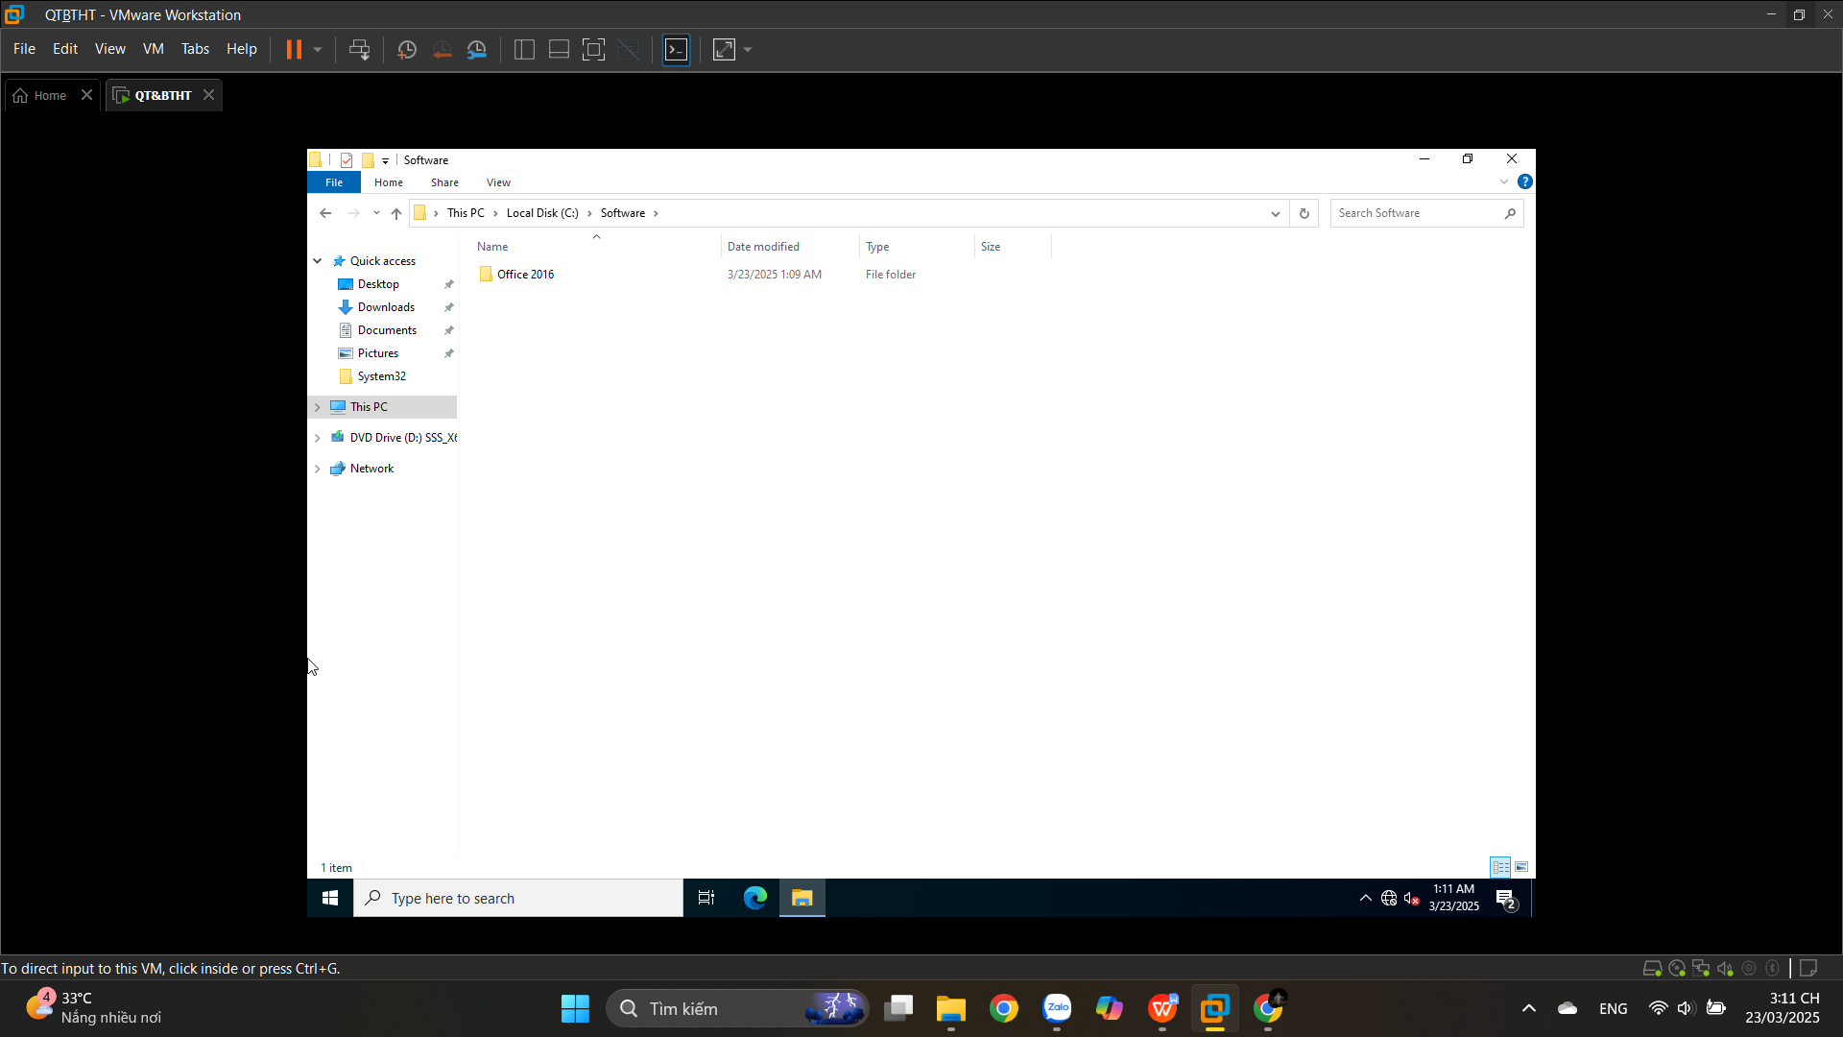

# **11. Configuring Security**

## **11.1. Windows Defender Security Center**

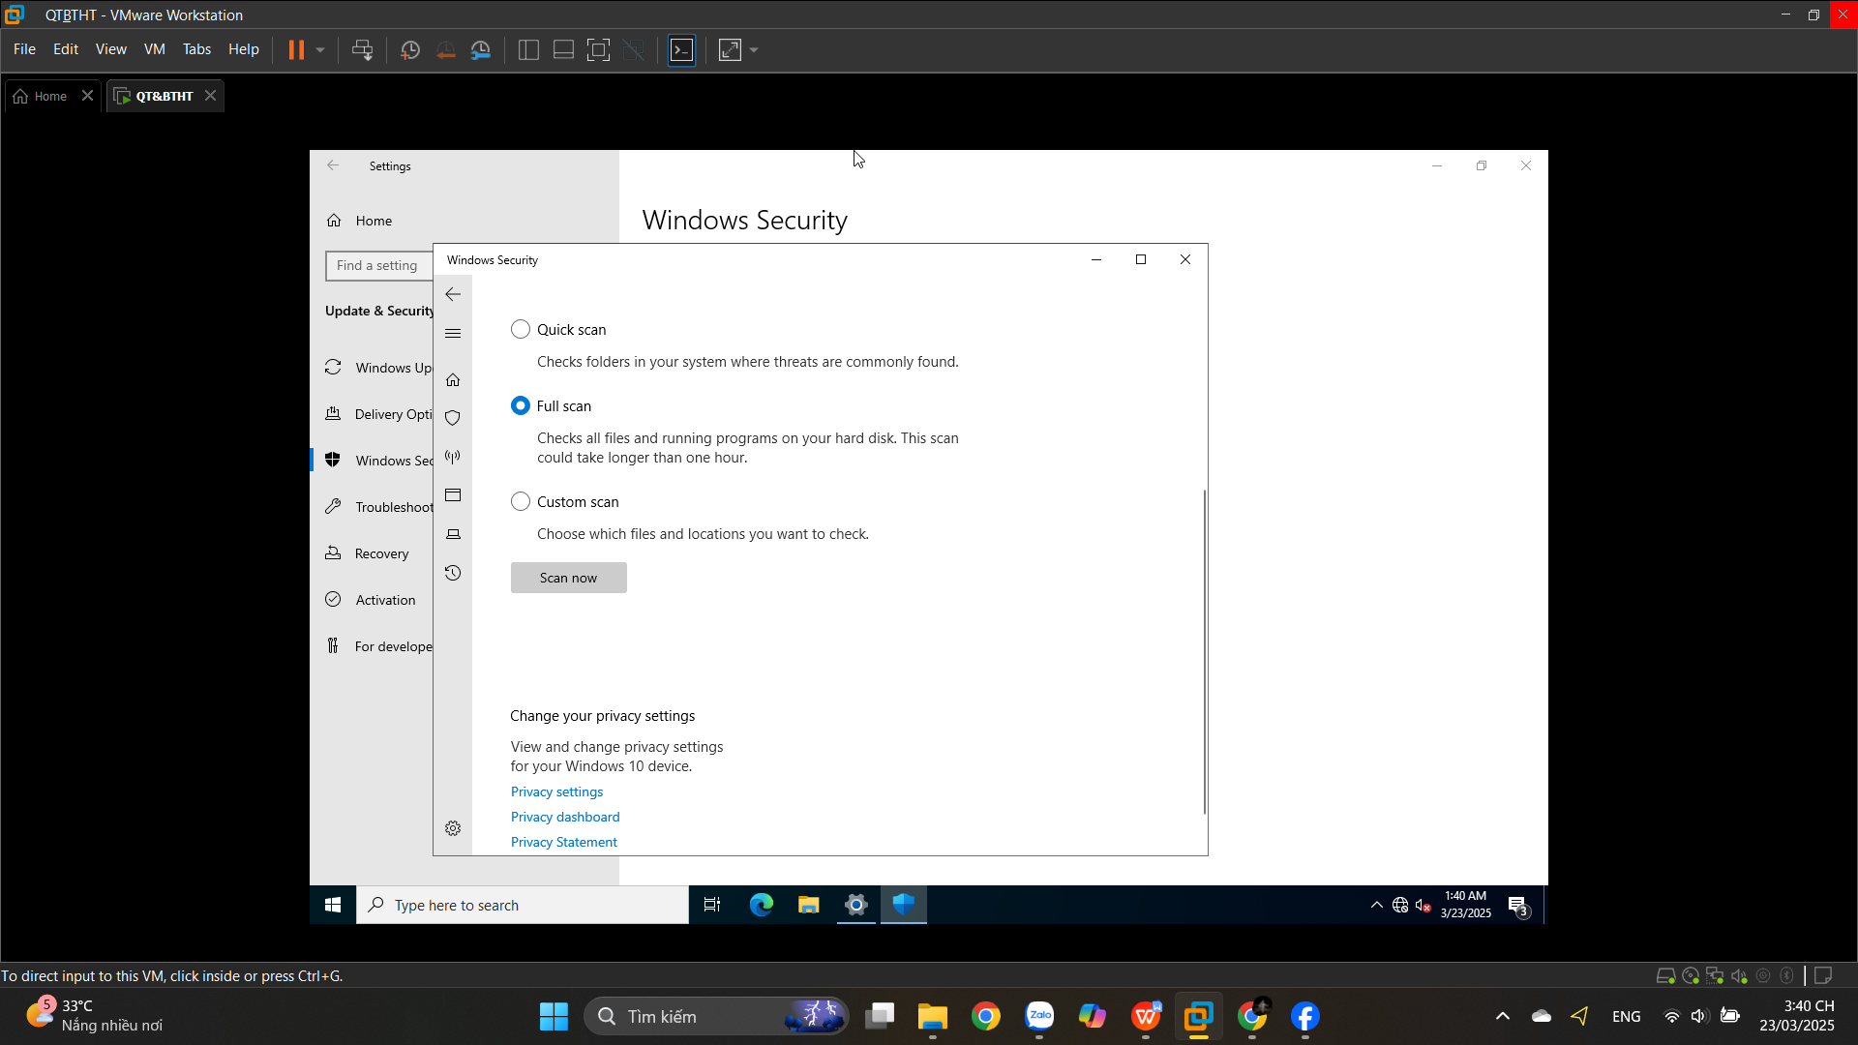

## **11.2. Configuring Windows Firewall**

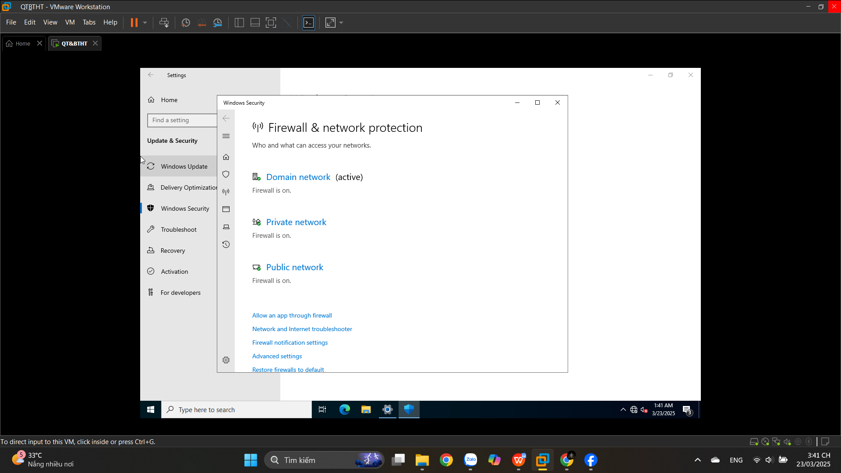

## **11.3. Windows Firewall with Advanced Security (WFAS)**

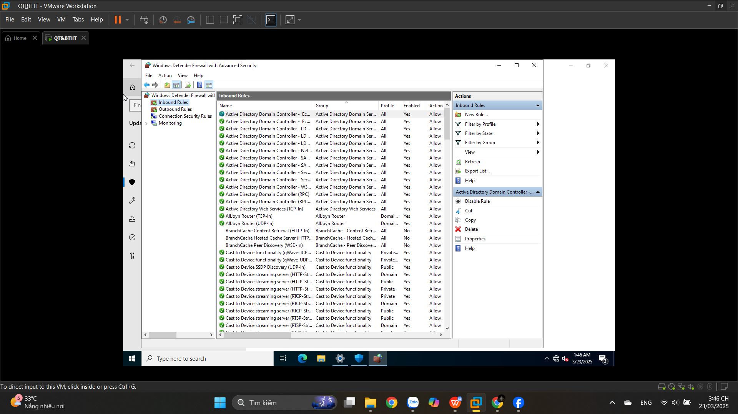

## **11.4. Installing Windows Defender Application Guard**